This document can be made available in alternative formats for people with specific requirements. If you would like the application in any of these formats please call the City’s Project Officer – Parks and Environment on 9273 6027 or mail@vincent.wa.gov.au
When you have completed this form, send it and any supporting material to:
Chief Executive Officer
City of Vincent
PO Box 82
Leederville 6902.
PLEASE RETURN THIS APPLICATION BY NO LATER THAN:
5.00pm Friday 24 March 2017

LATE APPLICATIONS WILL NOT BE ACCEPTED

DETAILS OF YOUR ORGANISATION
Name of Group………………………………………………………………….……….…......................

Postal Address...…………………...……………………………………………….……………………...

..…………………...…………………………………………….. Postcode…….………………………..

Telephone………………………………………………………. Facsimile……………………………...

Email ……………………………………………………………………………….…………………….....

PLEASE PROVIDE DETAILS of who in your group we can contact regarding your proposal.

Name………………………………………………………………………………………………………...
Position/title……………………………………………………………………..……………....................
Daytime telephone number……………………………………………………......................................

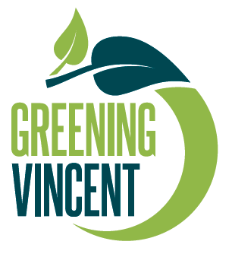

DESCRIBE WHAT YOU WILL USE THE GRANT FOR. Please describe the project you want to use the grant for, clearly and fully, telling us who will be involved and what the aim is.
………………………………………………………………………………………………………………………………………………………………………………………………………………………………………………………………………………………………………………………………………………………………………………………………………………………………………………………………………………………………………………………………………………………………………………
………………………………………………………………………………………………………………
………………………………………………………………………………………………………………………………………………………………………………………………………………………………
………………………………………………………………………………………………………………………………………………………………………………………………………………………………

HOW MUCH MONEY ARE YOU APPLYING FOR IN THIS APPLICATION? Please be aware that the maximum amount is $2,000.
……………………………………………………………………………………………………………….

ALL PROJECTS MUST COMMENCE BY AUGUST 2017 AND BE FINISHED BY AUGUST 2018. Please provide proposed project timeline.
……………………………………………………………………………………………………………….……………………………………………………………………………………………………………….……………………………………………………………………………………………………………….……………………………………………………………………………………………………………….
……………………………………………………………………………………………………………….
HOW WILL THE PROJECT/INITIATIVE RAISE COMMUNITY AWARENESS ABOUT THE
ENVIRONMENT AND/OR BENEFIT THE ENVIRONMENT?

……………………………………………………………………………………………………………….
……………………………………………………………………………………………………………….

……………………………………………………………………………………………………………….

……………………………………………………………………………………………………………….

……………………………………………………………………………………………………………….

……………………………………………………………………………………………………………….
……………………………………………………………………………………………………………….
WHAT WILL THE DEMONSTRATED OUTCOMES BE?

……………………………………………………………………………………………………………….……………………………………………………………………………………………………………….……………………………………………………………………………………………………………….……………………………………………………………………………………………………………….
……………………………………………………………………………………………………………….
……………………………………………………………………………………………………………….

WHAT COMMUNITY INVOLVEMENT IS PROPOSED?

……………………………………………………………………………………………………………….……………………………………………………………………………………………………………….……………………………………………………………………………………………………………….……………………………………………………………………………………………………………….
……………………………………………………………………………………………………………….……………………………………………………………………………………………………………….
……………………………………………………………………………………………………………….

PLEASE PROVIDE THE NAMES AND DETAILS OF TWO REFEREES who will know about your groups work and will be able to provide information on how your project will benefit people living in the City of Vincent:

Referee 1

Name……………………………………………………………………………………………………….Organisation……………………………………………………………………………………………….Position/Title……………………………………………………………………………………………….Daytime Telephone………………………………………………………………………………………...

Referee 2

Name………………………………………………………………………………………………………..Organisation………………………………………………………………………………………………..Position/Title………………………………………………………………………………………………..Daytime Telephone………………………………………………………………………………………...

BUDGET

Using the form over the page, please provide information about the costs and income for the service or program you are seeking funding for. In most cases, we do not require information about the costs and income of your entire group.

Please note the City of Vincent does not provide funding for salaries and wages or the purchase of machinery, office equipment, computers, motor vehicles or capital items.

However, the City of Vincent will provide funding to cover operations including, but not limited to, the cost of advertising and promotion (where required), the hire of equipment, fees for contractors and maintenance works.

If you would like any further information or assistance contact the Parks & Environment Officer on 9273 6000 or mail@vincent.wa.gov.au.

Please progress to the budget sheet over the page.

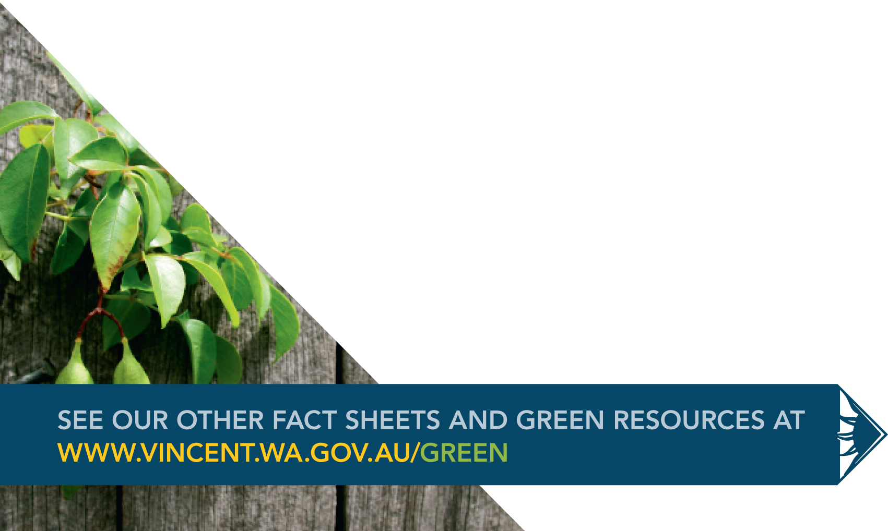

INCOME | $ | COST | $
City of Vincent Financial Assistance Grant (The amount of money you are applying for) |  | Costs of running the service or program (For example, hiring the venue, providing transport, buying materials and equipment, production) Please list your costs below:
Money from other government or grant organisations. Please list grants below: |  | Salaries, wages, fees. Please list your costs below:
Your own Groups cash contribution: |  | Costs of supporting the service or program (For example, photocopying, postage, database management, office work) Please list your costs below:
Money from private organisations (For example, businesses or individuals) Please list contributions below: |  | Marketing and Promotion (For example, designing flyers and brochures, printing, ads) Please list your costs below:
In kind support (For example, free venue, volunteer instructor, free advertising or promotion) Please list contributions below: |  | Other costs (please list):
TOTAL INCOME |  | TOTAL COSTS

IS YOUR GROUP INCORPORATED? YES NO
NO

If no, please attach a letter from an incorporated organisation that agrees to manage the funds for you. The City of Vincent will not give money to an unincorporated organisation.

If an incorporated organisation has agreed to manage the funds on behalf of your group, please include the organisation’s ABN and tell us whether it is registered for the GST in the questions below.

DOES YOUR GROUP HAVE AN AUSTRALIAN BUSINESS NUMBER (ABN)?

Yes
(Please write it here)………………………………………………………………………………………

No
(If your group is applying for an ABN please write the Australian Taxation Office registration number here) ………………………………………………………………………………………………

IS YOUR GROUP REGISTERED FOR THE GOODS AND SERVICES TAX?

Yes
No

CHECK LIST

- Have you answered every question?

- Completed the budget section?
- Provided the names and details of two referees?

- Provided your Australian Business Number (ABN)?

- Enclosed a supporting letter from an incorporated organisation if your
Organisation is not incorporated?

I have read the assessment criteria relating to this program. To the best of my knowledge the information about my Group and project is correct.
Applicant ……………………………..……………………………………………………..
Signature ………………………………………………… Date ………………………….
Name ………………………………………………………………………………………..

www.vincent.wa.gov.au/green

