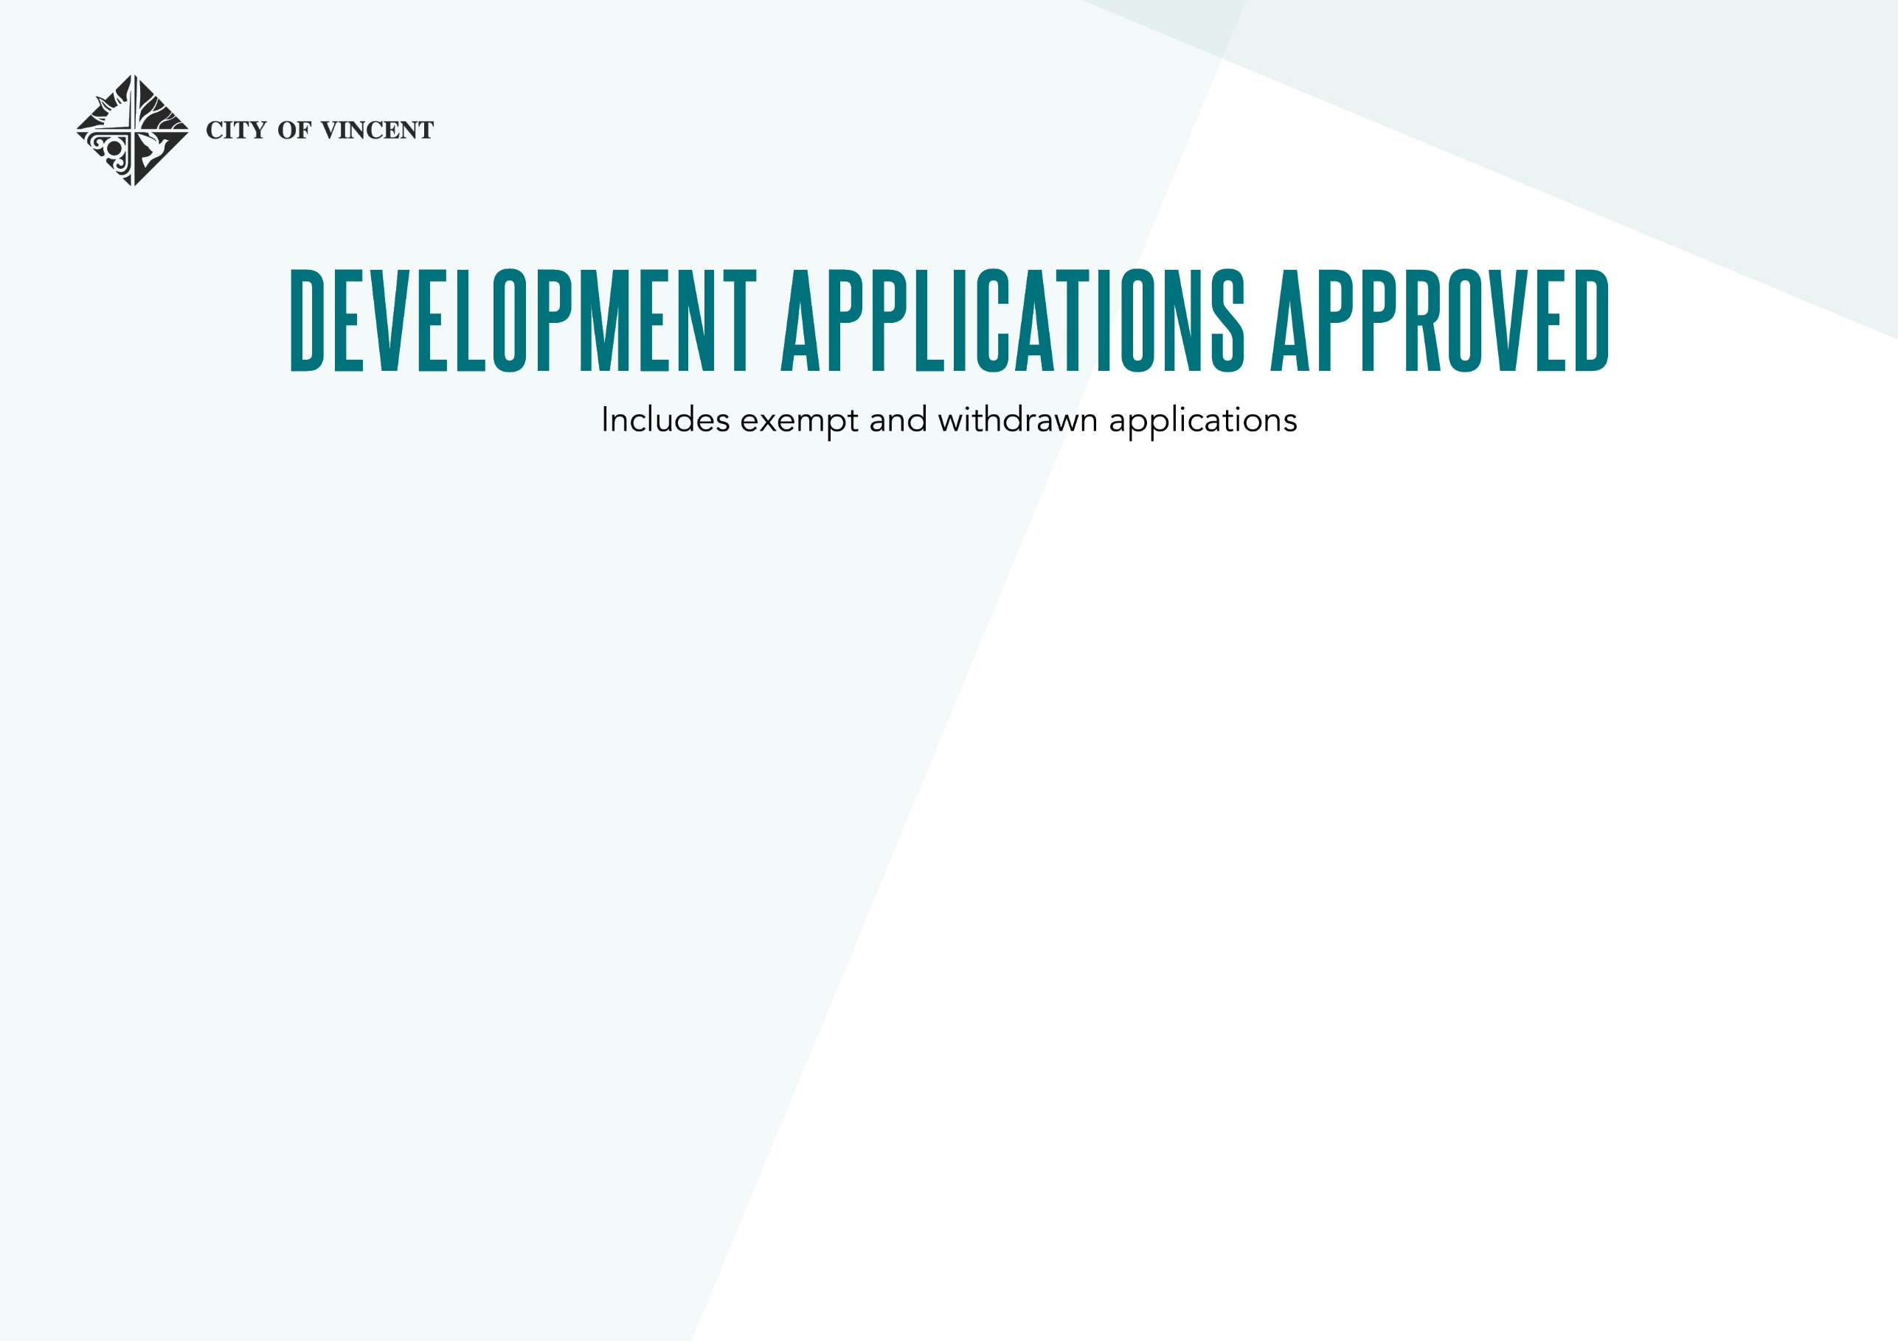
August 2022

Total number of applications determined | 27

Application Reference number | Property Address | Application Description | Value of Development | Decision
5.2021.438.1 | 46C Joel Terrace EAST PERTH | Multiple Dwellings (10)(JDAP) | $7,500,000.00 | Approval by External Authority - Add con
5.2021.465.2 | 636-640 Newcastle Street LEEDERVILLE | SAT S.31 Reconsideration Mixed Use Development (Amendment to Approved) | $0.00 | S.31 Reconsideration approved External
5.2021.481.1 | 208 Loftus Street NORTH PERTH | Alterations and Additions to Single House | $500,000.00 | Approval by Delegated Authority
5.2022.3.1 | 17-39 Robinson Avenue PERTH | Alterations and Additions to Commercial (Hotel) (JDAP FORM 1) | $12,000,000.00 | Approval by External Authority - Add con
5.2022.17.1 | 510 William Street HIGHGATE | Alterations and Additions to Single House | $451,620.00 | Approval by Delegated Authority
5.2022.29.1 | 72 The Boulevarde MOUNT HAWTHORN | Single House | $1,600,000.00 | Approval by Council - Officer Rec
5.2022.38.1 | 50 Paddington Street NORTH PERTH | Alterations and Additions to Single House | $600,000.00 | Approval by Delegated Authority
5.2022.43.1 | 357 Lord Street HIGHGATE | Mixed Use Development | $3,000,000.00 | Approval by Council - Officer Rec
5.2022.45.1 | 22 Sasse Avenue MOUNT HAWTHORN | Single House | $413,883.00 | Approval by Delegated Authority
5.2022.50.1 | 120 Raglan Road NORTH PERTH | Alterations and Additions to Single House | $368,330.00 | Approval by Delegated Authority
5.2022.54.1 | 9 Woodville Street NORTH PERTH | Change of use from (Single House) to (Aged Persons Dwelling)(including | $1,200,000.00 | Approval by Delegated Authority
5.2022.56.1 | 75 Forrest Street MOUNT LAWLEY | Alterations and Additions to Single House | $10,000.00 | Approval by Delegated Authority
5.2022.77.1 | 8 Blackford Street MOUNT HAWTHORN | Alterations and Additions to Single House | $250,000.00 | Approval by Delegated Authority
5.2022.78.1 | 29 Marian Street LEEDERVILLE | Alterations and Additions to Single House | $4,000.00 | Approval by Delegated Authority
5.2022.88.1 | 43A Clieveden Street NORTH PERTH | Grouped Dwelling | $800,000.00 | Approval by Delegated Authority
5.2022.101.1 | 522 William Street HIGHGATE | Alterations and Additions to Single House | $175,000.00 | Approval by Delegated Authority
5.2022.102.1 | 31 Smith Street HIGHGATE | Alterations and Additions to Place of Worship (crucifix) | $224.00 | Approval by Council - Officer Rec
5.2022.103.1 | 7 Gardiner Street EAST PERTH | Alterations and Additions to Single House | $550,000.00 | Approval by Delegated Authority
5.2022.116.1 | 10 Waugh Street NORTH PERTH | Alterations and Additions to Single House (Patio) | $17,454.00 | Approval by Delegated Authority
5.2022.119.1 | 13 Lynton Street MOUNT HAWTHORN | Single House | $750,000.00 | Approval by Delegated Authority
5.2022.122.1 | 17 Lynton Street MOUNT HAWTHORN | Alterations and Additions to Single House (Carport) | $10,800.00 | Approval by Delegated Authority
5.2022.126.1 | 29 Paddington Street NORTH PERTH | Alterations and Additions to Single House (Carport) | $30,000.00 | Approval by Delegated Authority
5.2022.141.1 | 29 Marian Street LEEDERVILLE | Grouped Dwelling | $400,000.00 | Approval by Delegated Authority
5.2022.143.1 | 30 Killarney Street MOUNT HAWTHORN | Alterations and Additions to Single House | $240,000.00 | Approval by Delegated Authority
5.2022.156.1 | 117 Fairfield Street MOUNT HAWTHORN | Alterations and Additions to Single House (Ancillary Dwelling) | $135,000.00 | Approval by Delegated Authority
5.2022.184.1 | 13 Blake Street NORTH PERTH | Eight multiple dwellings and conversion of existing | $40,000.00 | Approval by Delegated Authority
5.2022.202.1 | 80 Ellesmere Street MOUNT HAWTHORN | Single House (Amendment to Approved) | $0.00 | Approval by Delegated Authority

